Jamie Michael Brady
May 17, 1968 - December 1, 2023

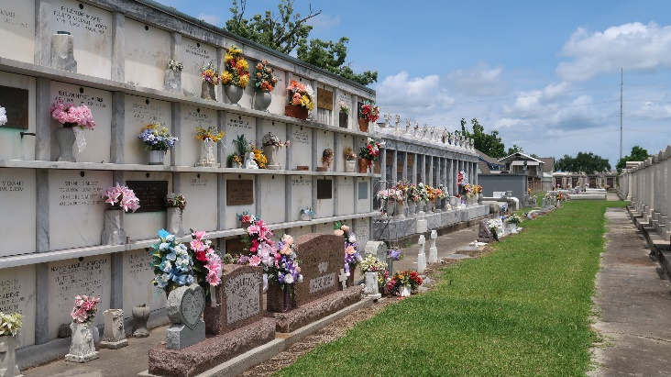

Jamie Michael Brady was welcomed into the gates of Heaven on Friday, December 1, 2023, at the age of 55. No longer suffering from his battle with Chronic Lymphocytic Leukemia (CLL), Jamie is now with his Heavenly Father. Born in Reserve, LA, he was a resident of LaPlace, LA for the past 25 years.
Jamie is the beloved husband of Shantele Adcock Brady and loving father of Saige Brady Merrill (Corey) and Jade Brady (Dane); son of Rosalyn “Totsy” Brady and the late Armand Brady, and son-in-law of Kenneth and Theresa Adcock; brother of Angel Delaneuville (Jimmy); brother in law-to Quinten Adcock (Megan); godfather of Colby Thompson (Kaitlyn) and uncle to Shelby Torres (Brent), Jenna Adcock, and Brynn Adcock.
Jamie is a 1986 graduate of St. Charles Catholic High School in LaPlace. He attended Delgado Community College where he played baseball and then transferred to the University of Louisiana at Lafayette where he was an Eta Nu Chapter member of Sigma Nu Fraternity. He graduated from Louisiana at Lafayette in 1992. Jamie began his career as process operator and previously worked as a contract coordinator at Denka, formerly known as Dupont, for more than 25 years.
When he was not at work, Jamie could be found at the ball field helping coach the St. Charles Catholic Lady Comets softball team, spending time with his family, or cleaning his beloved 2002 Chevrolet Silverado. He also loved listening to Swamp Pop, watching sports, and supporting his two daughters’ many extracurricular activities.
Most of all, he loved God and his family. Jamie was a man who lived by faith, loved people, his community, and sports. He will forever be in the hearts of many.
Visitation will be held on Tuesday, December 5, 2023, from 6:00 PM to 9:00 PM at Millet Guidry Funeral Home, 806 W. Airline Hwy. in Reserve. Recitation of the rosary will be at 7:00 p.m. Visitation will continue at Millet- Guidry Funeral Home on Wednesday, December 6, 2023, from 9:00 a.m. until 10:00 a.m. A Funeral Mass will be celebrated at 11:00 a.m. at St. Joan of Arc Church in LaPlace. Burial will be in St. Peter Cemetery, Reserve.
In lieu of flowers, donations may be made to St. Charles Catholic High School, 100 Dominican Drive, LaPlace, LA 70068, in memory of Jamie Brady.

Millet-Guidry Funeral Home, LaPlace, Louisiana
December 2, 2023

