Mildred (Michel) Brady
August 23, 1912 – March 28, 1964

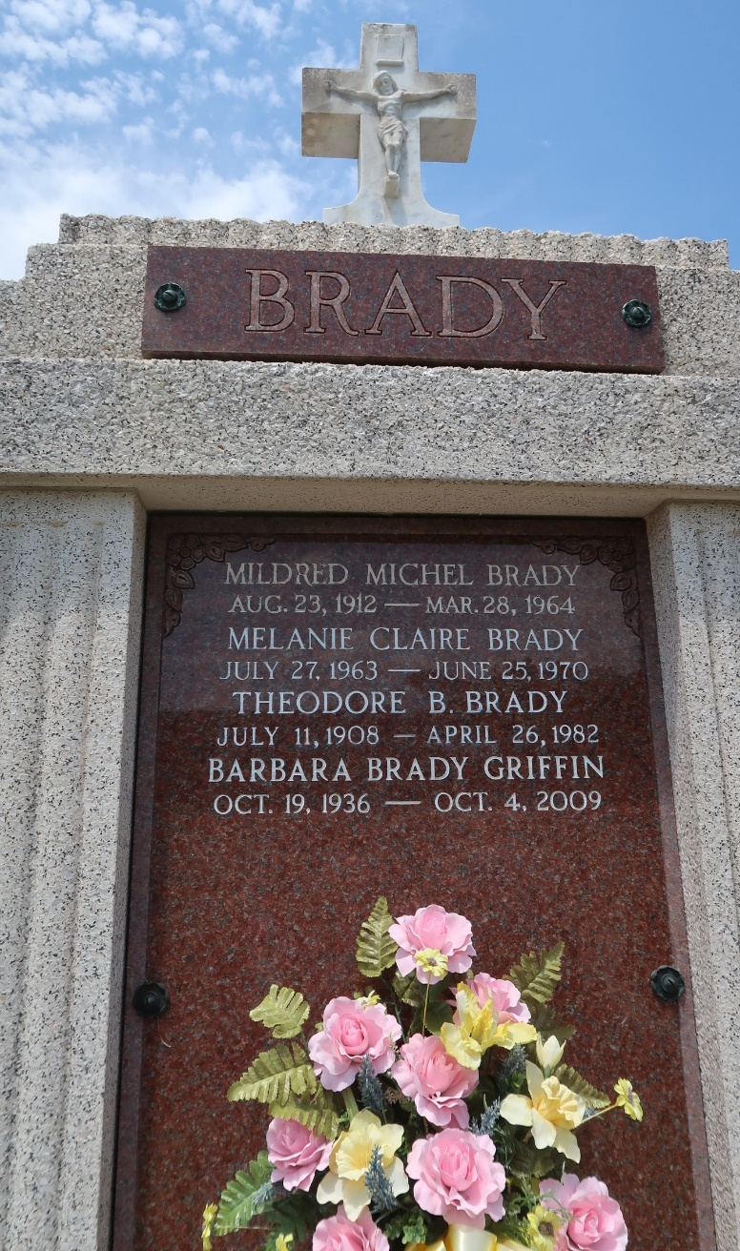

Age 51 years, a native of Gramercy, Louisiana, and a resident of Laplace, Louisiana.

Wife of Theodore Brady, mother of Mrs. Barbara Brady Griffin, Theodore Jr and Patricia Ann Brady, all of Laplace.

Daughter of Mrs. Jules Michel Sr of Gramercy and sister of Lawrence and Jules Michel Jr of Gramercy, Floyd Michel of Garyville, Louisiana, and Mrs. Florence St Pierre of Houma, Louisiana.

Services were Monday, 30 March 1964 at St Joan of Arc Church, Laplace, with interment in St Peter Cemetery, Reserve, Louisiana.
The Times-Picayune, New Orleans, Louisiana
Monday, March 30, 1964

