Sidney Joseph Brady
March 8, 1910 – October 8, 1999

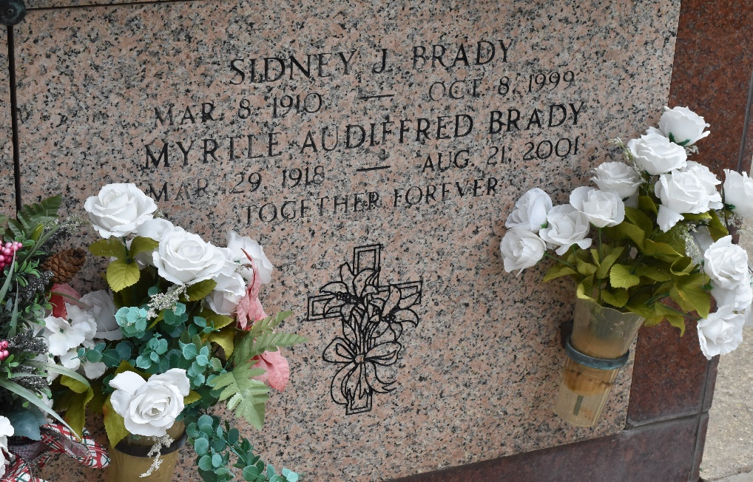

Sidney J Brady died on Friday 8 Oct 1999 at 11:00 AM.

He was the husband of Myrtle Audiffred Brady and father of Brynn Conrad and Sylvia Shanklin. Grandfather of Clifton J Conrad Jr, Carter A Shanklin III, and the late Mandy and Sylvia Diane Shanklin. Survived by one great grandchild. Age 89 years, a native and resident of Laplace, Louisiana.

Relatives and friend of the family are invited to attend the funeral services at Millet Guidry Funeral Home, 2806 West Airline Hwy, Laplace, Louisiana, on Monday 11 Oct 1999 followed by religious services at St Joan of Arc Church, Laplace. Interment in St Peter Cemetery, Reserve, Louisiana.
L'Observateur, LaPlace, Louisiana
October 9, 1999

