Michael Russel Breaud
July 15, 1944 – June 14, 2023

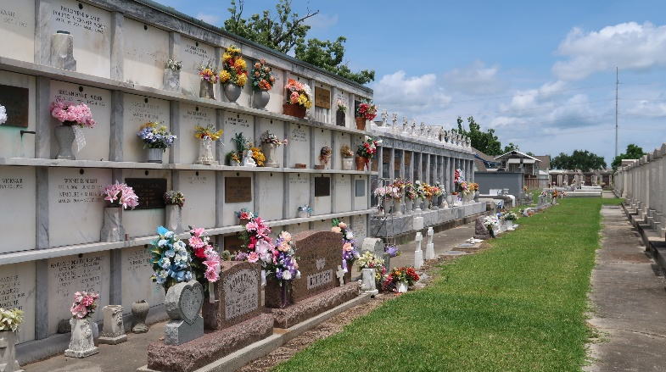

Michael Russel Breaud passed away peacefully on June 14, 2023 at the age of 78. He was born in Reserve, LA on July 15, 1944 and spent the last 30 years living on the ground he grew up on. He was the third of nine children born to Felix James Breaud, Sr. and Noelie Weber Breaud. Mike graduated from Leon Godchaux High School in 1962 and enlisted in the Army for three years immediately after. He spent a year in Korea where he worked on Nike missiles and was a part of the Cuban Missile Crisis. He was a true patriot and avid supporter of the United States Military.
Mike retired in 1999 after 30 years as a machinist at Kaiser Aluminum. He was a proud member of United Steelworkers of America Local 5702 Dist. 36. He was a simple man who enjoyed the outdoors, hunting, fishing, and growing his garden. He raised rabbits and had a significant love of birds, especially cockatiels. Mike Bro could be found any given day with a Budweiser in his hand anywhere from Manchac to Lutcher at one of his favorite watering holes. He would leave if the music was too loud, which is strange since he couldn’t hear it anyway!
Mike is survived by his son Shannon James Breaud of Reserve, and loving daughter Dawn Marie Breaud Lucia. Also survived by his two grandsons; he was immensely proud of: Dr. Ryan Michael Breaud and Zachary Shannon Breaud. He is also survived by his siblings, Carolyn Breaud Oncale, Ronald (S***Head) Breaud, Donald (Pluck) Breaud, Sherri Breaud Caronna, Ricky Paul Breaud, and a host of nieces and nephews.
Mike is preceded in death by his parents Felix James Breaud, Sr. and Noelie Weber Breaud, his grandparents Noe Jules Weber and Norma Jacob Weber, and Henry Breaud and Martha LeBlanc Breaud.
Relatives and friends are invited to attend the Visitation and Funeral Service at Rose Lynn Funeral Home, 1870 Cabanose Ave., Lutcher, LA on Tuesday, June 20, 2023. Visitation from 9:00 a.m. to 11:00 a.m. followed by a Funeral Service at 11:00 a.m. Interment in St. Peter Cemetery, Reserve, LA. Please join us at Airborne Bar for one last beer on Mike’s tab, 1504 River Road, LA-44 Reserve after the burial.
In lieu of flowers, the family requests donations be made to the Wounded Warrior Project, as this was one of Mike Bro’s favorite charities!

Rose Lynn Funeral Home, Lutcher, Louisiana
June 15, 2023

