Alvin "Al" Brignac Jr.
August 29, 1953 – June 16, 2024

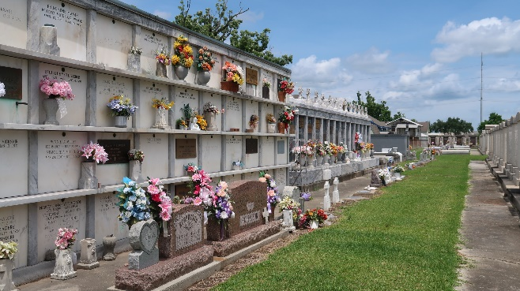

Alvin “Al” Brignac Jr., age 70, a resident of Gonzales, La, passed away on Sunday, June 16, 2024, surrounded by his loving family. Al was a member of St. Mark Catholic Church, the St. Mark Men’s Club and the Men’s Prayer Group. He was also a member of the Knights of Columbus. He loved spending time with his family, especially the grandkids. He enjoyed working in his sculpture garden, caring for his rose bushes, and being a devout Catholic dedicated to Blessed Francis Seelos and the Blessed Virgin Mary.
He is survived by his wife of 29 years, Debra Terrebonne Brignac; mother, Delores Petit Brignac; daughter, Kelly Gibson (Travis); sons, Cory Brignac (Renee), Wesley Bonstaff (Melissa), Christopher Bonstaff (Karlie); grandchildren, Cori, Caroline, Rowan, Zane, Brynley, Abigail, Elise, Chloe, Ryleigh, Braydon, Remington and one on the way; sister, Sharri Deslatte (Lonnie); brother, Terry Brignac (Donna) and numerous nieces, nephews, family and friends. He was preceded in death by his father, Alvin Brignac Sr.
Visitation for Al will be on Thursday, June 20, 2024, from 6 pm to 8 pm at St Mark Catholic Church and will resume on Friday, June 21, 2024, from 9 am until Mass of Christian burial at 11 am at St. Mark Catholic Church, 42021 Hwy 621, Gonzales, La. Burial will be at 2 pm at St. Peter Cemetery, Reserve, La. Pallbearers will be Cory Brignac, Wesley Bonstaff, Chris Bonstaff, Ryan Madere, Ryan Brignac and Travis Gibson.
In lieu of flowers, please consider having Masses said at St. Mark Catholic Church in his honor.

Ourso Funeral Home, Gonzales, Louisiana

