Bessie (Keller) Brignac
November 15, 1909 – October 9, 2004

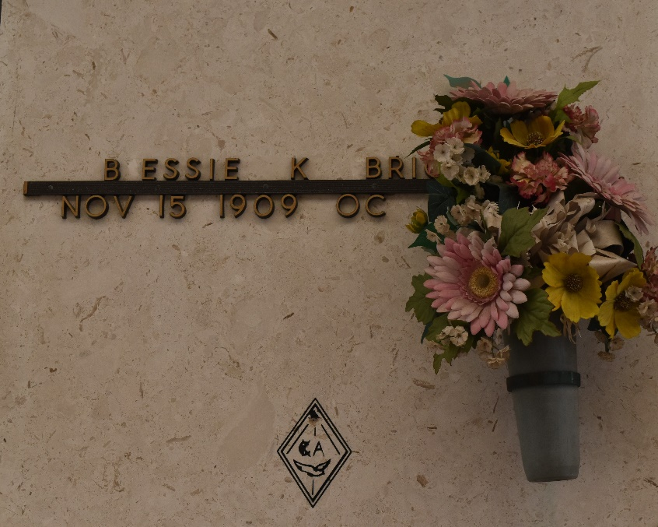

RESERVE - Bessie Keller Brignac, 94, a native of Montz and resident of Reserve for 70 years, died Oct. 9.

She was the wife of the late Albert Brignac Sr., and mother of Jackie Labat and Albert Brignac Jr. She was also the daughter of the late Wilford and Georgiana Perilloux Keller, and sister of Corinne McMillian, Evelyn Brady, and the late Earl Keller. She is also survived by 11 grandchildren, 34 great-grandchildren, two step-great-grandchildren and three great-great-grandchildren.

Services were Oct. 11 at St. Peter Catholic Church, Reserve, with interment at the church cemetery.
L'Observateur, LaPlace, Louisiana
Thursday, October 14, 2004

