Karen (Weber) Brignac

May 21, 1971 – September 2, 2001

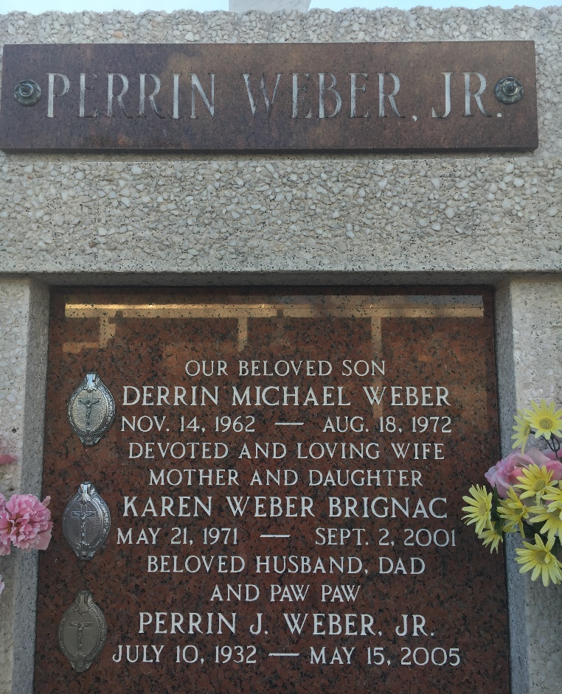

Photo by Team T-Lo

NORCO - Karen Weber Brignac, 30, a native of New Orleans and resident of Norco, died Sept. 2.

She was the wife of Chad Brignac and mother of Jadelynn McKay and Walker Michael Brignac. She was the daughter of Perrin Jr. and Catherine Duhe Weber and sister of Duane and the late Derrin Weber.

Services were Sept. 7 in the chapel of H.C. Alexander Funeral Home, Norco, with interment at St. Peter's Cemetery.

L'Observateur, LaPlace, Louisiana

September 8, 2001