Jean Joseph Florentin Brochier
March 30, 1904 – August 15, 1936

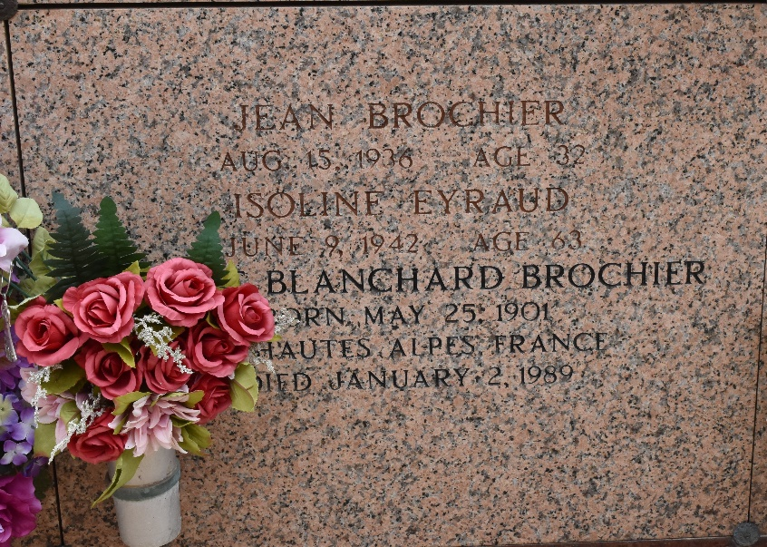

Jean Brochier died Saturday 15 Aug 1936. He was the husband of Ellen Blanchard and father of Jeannette Brochier and the nephew of the Very Reverend John M Eyraud. He was aged 32 years and a native of Gap, Hautes Alps, France, and a resident of Reserve, Louisiana, for the past 13 years.

Jean, his wife (H)Ellen, and his aunt, Isoline Eyraud, arrived in New Orleans on the SS De La Salle from Le Havre on 1 Jul 1923 and lived in Reserve with Rev. Jean Eyraud.

Services were Sunday 16 Aug 1936 from the Jules Millet Funeral Home, Reserve, with religious services at St Peter Church, Reserve. Interment was in St Peter Cemetery.
The Times-Picayune, New Orleans, Louisiana
August 16, 1936

