Virgie (Vicaro) Broussard
1930 – August 5, 2014

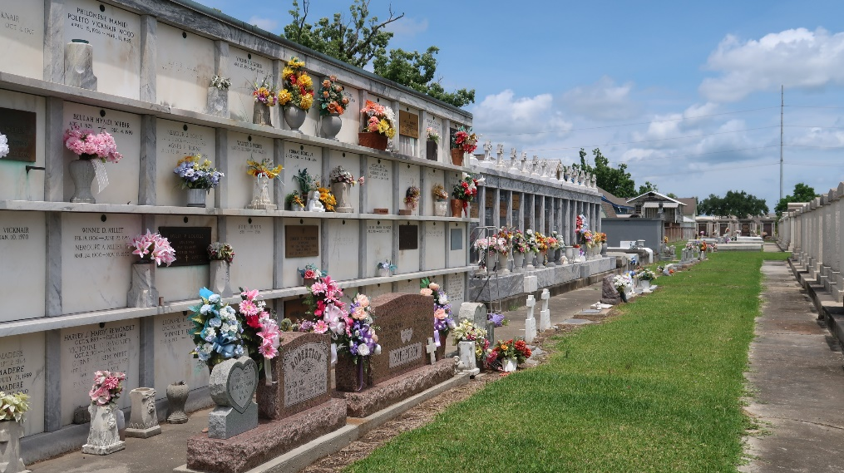

Virgie Vicaro Broussard died on Tuesday August 5, 2014, at the age of 84. A native of Baton Rouge.

Virgie is survived by her husband Marion, and their eight children: Marianne and husband Dean Wolfe, Michael and wife Mary Alice, Steven and wife Wanda, David and wife Nancy, Brion and wife Jenny, Kenneth and wife Diane, son Craig and daughter Beth Roussel; also survived by 17 grandchildren and twenty-two great-grandchildren.

She was preceded in death by infant son Matthew, twin great-grandchildren Halle and Evan, parents Mary and Joseph Vicaro and sister Cecile Lee.

TheNewOrleansAdvocate.com
Aug. 7, 2014

