Felice Amelia (Creecy) Brown
December 5, 1923 – June 13, 2012

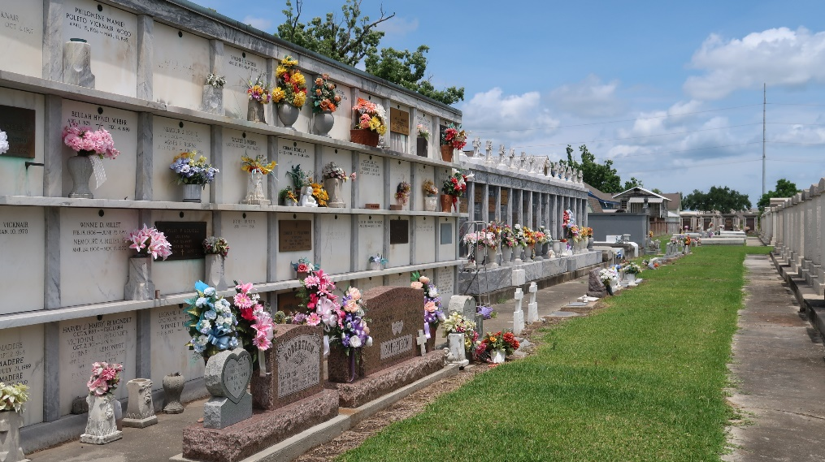

BROWN FELICE ANDERSON BROWN on Thursday, June 13, 2013 at her home in LaPlace, LA. Daughter of the late Bertha and Octarve Creecy. Wife of the late Freddie Anderson and Johnny Brown. Mother of Mary Ann Parquet, Octarve Anderson, Freddie Lee Brown, Randolph Anderson, Anita Clement, Clayton Anderson, Elise Perrilloux, Joey Anderson, Brenda Exxum, the late Audrey Wilson, Silvia, Larry and Danny Anderson. Sister of Mildred Wright, the late Myrtle Seymour and Frank Poche. Also survived by 32 grandchildren, 62 great grandchildren, 6 great great grandchildren and a host of nieces, nephews, other relatives and friends. Age 89 years. A native of Montz, LA and resident of LaPlace, LA Relatives and friends of the family, also priest and parishioners of Our Lady of Grace Catholic Church and all neighboring churches are invited to attend the Funeral Mass at Our Lady of Grace Catholic Church, 772 Highway 44, Reserve, LA on Wednesday, June 19, 2013 at 10:00 AM. Father Julius Oloniyo, Celebrant. Interment St. Peter Cemetery, Reserve, LA. Visitation at the above named church from 8:30 AM until Mass time. Rosary at 9:00 AM SERVICED BY ROBOTTOM
The Times-Picayune, New Orleans, Louisiana
Jun. 15 to Jun. 16, 2013

