Floyd F. Brown

October 27, 1938 – May 24, 2010

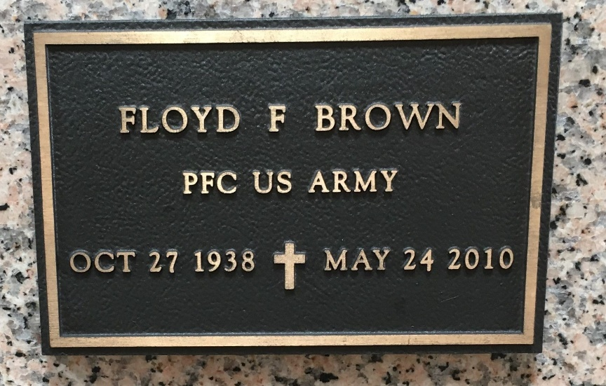

Floyd F. Brown passed away on Monday, May 24, 2010.

Husband of Diana Ockmond Brown. Father of Raymond Brown, Caren Owen and husband Tim and Corey Brown and friend Mitzi Colligan. Grandfather of Taylor and Christopher Owen and Tiffany, Alyssa and Branden Brown.

Son of the late Alfred (Doc) and Bernadette Jacob Brown. Brother of Joseph Brown, Myrtle Berteau, Carrol Bordelon, Betty Vicknair, Elsie Keressi and the late Shirley Tamplain and Beverly Brown.  
  
The Times-Picayune, New Orleans, Louisiana

May 25, 2010