Johnny Brown
January 26, 1918 – April 2, 2009
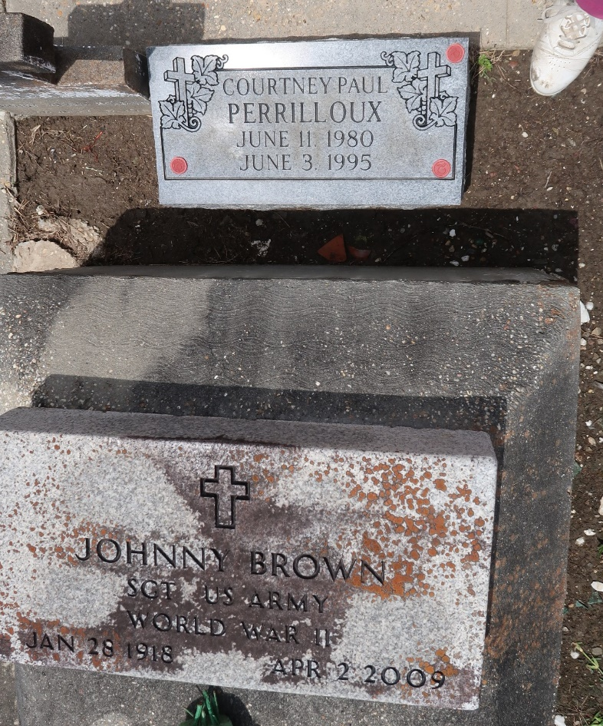

Johnny Brown On Thursday, April 2, 2009 At River Parishes Hospital, Laplace, La. Age 91 Years. A Native Of Montz, La And A Resident Of Laplace, La
Son Of The Late Rosa Lewis And Alfred Brown.
Husband Of Felice Brown.
Father Of Artis Smith And Stephanie Brown.
Stepfather Of Mary Parquet, Freddie Lee Brown, Anita Clement, Elise Perrilloux, Brenda Exxum, Octarve, Randolph, Clayton, Joey And Danny Anderson, The Late Audrey Wilson, Sylvia And Larry Anderson.
Brother Of The Late Melvin Brown.
Also Survived By 10 Grandchildren, 5 Great Grandchildren, A Host Of Nieces, Nephews, Other Relatives And Friends.
The Times-Picayune, New Orleans, Louisiana
April 7, 2009

