Deanna (Bivona) Caillouet
February 2, 1960 – September 21, 2013

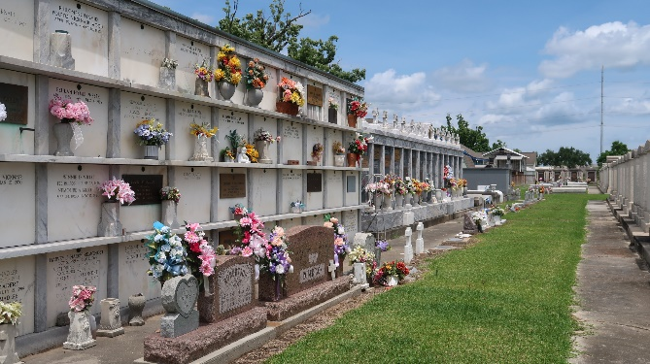

Deanna Bivona Caillouet died on Saturday September 21, 2013, Beloved mother of Lacey and Darren Caillouet Jr. Daughter of Isabelle Bivona and the late Leon Bivona. Also survived by 4 sisters and 3 brothers. Age 53. A native of Montz, LA and a resident of Garyville, LA.

Relatives and friends are invited to attend services. Visitation at Millet-Guidry Funeral Home, 2806 W. Airline Hwy., LaPlace, LA on Sunday September 22, 2013 from 5:00pm to 9:00pm and on Monday from 11:00am to 12:30pm, followed by Mass at St. Hubert Catholic Church, Garyville, LA at 1:00pm. Burial in St. Peter Cemetery, Reserve, LA.
TheNewOrleansAdvocate.com
September 21 - 22, 2013

