Joseph Calcagno
February 4, 1937 - May 14, 2024

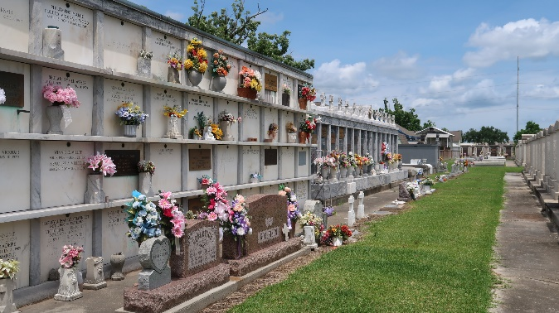

Joseph Calcagno passed away at his residence surrounded by his loving family on Tuesday, May 14, 2024 at the age of 87. He was a lifelong resident of Montz, LA. Joe was in the U. S. Airforce and after was the Manager of Airline Motors Restaurant. He did odd jobs but had a love for farming and fishing.
Beloved husband of almost 66 years to Sherry LaBranche Calcagno. Loving father of David Calcagno (Kathleen), Terry C. Landry (Glen) and Randy Calcagno. Grandfather of Danielle C. Coburn (Michael), Jesse Landry (Amber), David “D.J.” Calcagno, Jr., and the late Brian Landry (Amanda). Great grandfather of Hailey Rae, McKenzie, Harley, Kara, Madelyn, Emma and Sam. Son of the late Salvador Samuel “Sam” Calcagno, Sr. and Lonnie Dupre Calcagno. Brother of Salvador “Sal” Calcagno, Jr., Rose Faucheaux (Daniel) and the late Santa Mae Chester, Charles Calcagno and Laure Benenate. Also survived by many nieces and nephews.
The family would like to give a special thanks to all the caregivers of Vital Caring Hospice who looked after him.
Relatives and friends are invited to attend the Funeral Service at Millet-Guidry Funeral Home, 2806 W. Airline Hwy., LaPlace on Friday, May 17, 2024. Visitation will be held from 9:00 a.m. to 11:00 a.m. with the Funeral Service to immediately follow in the Chapel at 11:00 a.m. Interment in St. Peter Cemetery.

Millet-Guidry Funeral Home, LaPlace, Louisiana
May 16, 2024

