Loney (Dupuy) Calcagno

February 21, 1910 – September 11, 2004

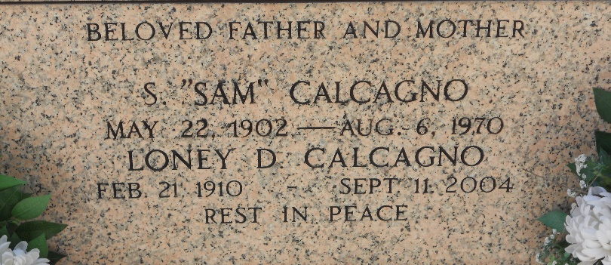

Photo by Team T-Lo

Loney Dupuy Calcagno (Maw Maw Sam), age 94, died September 11, 2004 in Montz, LA.  
 She was preceded in death by her beloved husband, Samuel (Sam) Calcagno; parents, Joseph Dupuy and Laurentine Berthelot Dupuy; daughter, Santa Mae Chester; brothers, Noah, Clemont, Nelson and Ernest Dupuy; sisters, Eunice Fontenot, Clementine Weber, Azelia Crane, Lillian Russell and Lezima Deslatte.  
 Survived by children, Charles Calcagno of LaPlace, Joseph Calcagno of Montz, Samuel (Sal) Calcagno, Jr. of Montz, Laure Benenate of Chalmette and Rose Faucheux of LaPlace. Also survived by 15 grandchildren, 29 great grandchildren and 2 great great grandchildren.  
 Mass of Christian Burial will be Tuesday, September 14, 2004 at 10:00am at Sacred Heart of Jesus Catholic Church in Norco. Visitation with the family will be Monday, September 13, 2004 from 5pm until 9pm and Tuesday 8:00am until 9:30am at H. C. Alexander Funeral Home in Norco. Entombment will be at St. Peter's Mausoleum in Reserve.  
 The family would like to express their sincere thanks to the River Region Hospice especially Patty, Jan, Anna and Ms. Anne Jean Bell.  
  
The Times-Picayune, New Orleans, Louisiana

September 12-13, 2004