Salvadore ‘Sam’ Calcagno

May 22, 1902 – August 6, 1970

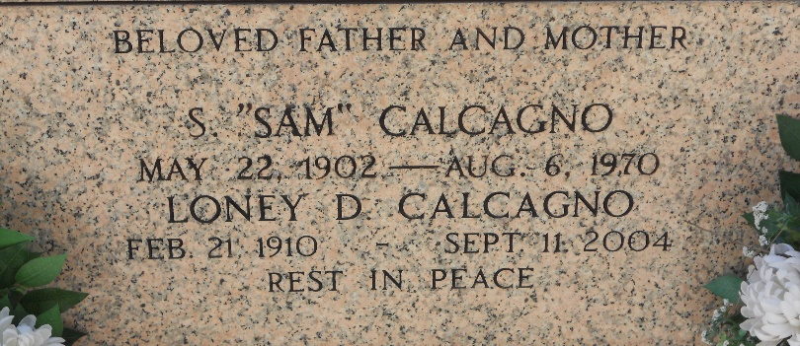

Photo by Team T-Lo

Salvador (Sam) Calcagno, On Thursday, August 6, 1970, At 4:45 O'clock A.M.; Beloved Husband Of Loney Dupry Calcagno; Father Of Charles Calcagno Of Laplace, La., Mrs. Robert Chester, Joseph Calcagno, Salvador Calcagno, Jr., All Of Montz, La., Mrs. Nathan Benenate Of New Orleans, La.,  
And Mrs. Daniel Foucheaux Of Laplace, La; Son Of The Late Santa Cambise And Charles Vincent Calcagno Also Survived By 14 Grandchildren; Age 68 Years; A Native Of Reserve, La., And A Resident Of Montz For The Past 66 Years.

Relatives And Friends Of The Family Are Invited To Attend The Funeral. Services From H. C. Alexander Funeral Home, Inc. 821 Fourth Street, Norco, La., On Friday, August 7, 1970, At 10:0O'clock A.M. Religious Services At Sacred Heart Of Jesus Church, Norco, La. Interment In St. Peter’s Cemetery, Reserve, La. Recitation Of The Rosary By The Holy Name Society On Thursday At At 8:30 P.M., And By The Ladies Altar Society, Friday At 9:20 O'clock A.M.  
  
The Times-Picayune, New Orleans, Louisiana

August 7, 1970

Page 16, Column 2