Santa (Compsi) Calcagno
1865 – January 10, 1944

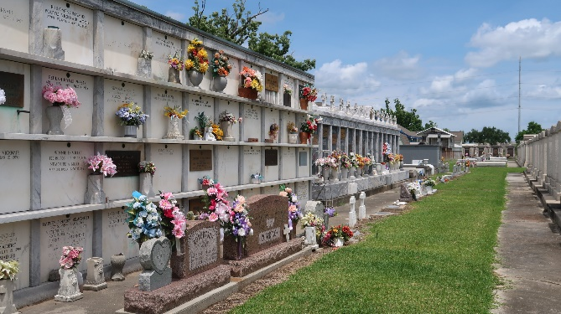

At The Residence On Monday, January 10, 1944, At 7:00 Pm Santa Compsi Of Montz, La., Wife Of The Late Vincent Calcagno, Mother Of Salvador And Joseph And The Late Mrs. Charles Ferteta, Sister Of Vincent Compsi, Also Survived By 23 Grandchildren And Six Great Grandchildren, Aged 74 Years, A Native Of Palermo, Italy And A Resident Of Montz, La. For 40 Years.

Relatives And Friends Are Invited To Attend The Funeral Which Will Take Place At 10:00oclock Am On Wednesday, January 12, 1944, From The Late Residence Montz, La. Religious Services At St. Peters Church, Reserve, La. Interment In St. Peter's Cemetery. Lamana Panno Fallo, Inc., In Charge.
The Times-Picayune, New Orleans, Louisiana
January 12, 1944
Page 2, Column 6

