Rita (Abadie) Camallo
November 14, 1919 – August 24, 2008

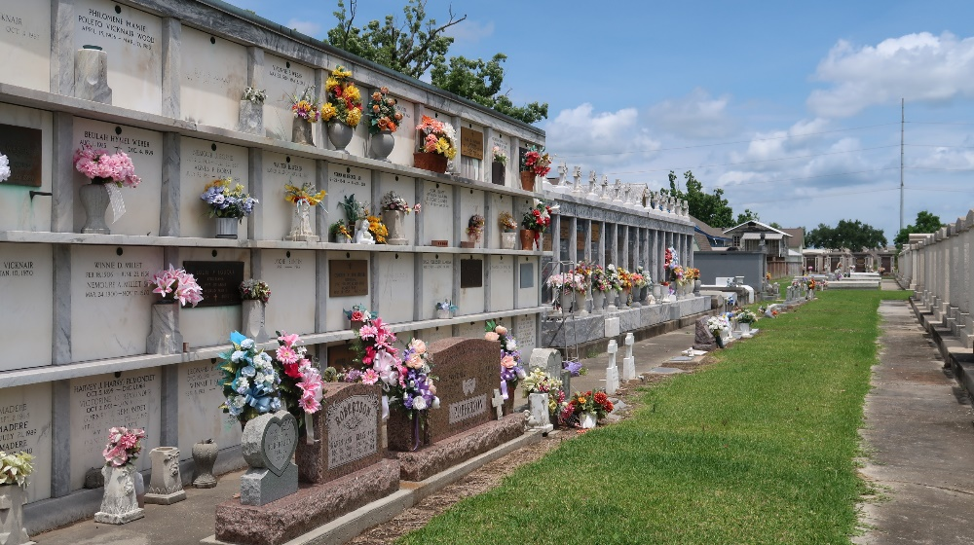

Rita Abadie Camallo on Sunday, August 24, 2008 at 4:00PM. Beloved wife of the late Salvador (Mike) Camallo. Mother of Kathy Camallo, Brenda Condrey, Becky Davis and the late Michael Camallo. Also survived by 5 grandchildren and 9 great-grandchildren. Daughter of the late Amedee A. and Ada Waguespack Abadie. Sister of Vivian Huber, Leo Abadie, Jerry Abadie, Amedee J. Abadie and Conrad Abadie also the late Antoinette Roussel, Ruth Walter Casse, Mabel Garland, Maurice, Vernon, Harold and Lyman Abadie. Age 88 years. A native of Wallace, La. and a resident of LaPlace, La.

Relatives and friends are invited to attend services. Visitation at Millet-Guidry Funeral Home, 2806 W. Airline Hwy., LaPlace, La., on Thursday, August 28, 2008 from 10:00AM to 12:00PM. Followed by Religious Services at the Funeral Home Chapel at 12:00Noon. Burial in St. Peter Cemetery Reserve, La.
The Times-Picayune, New Orleans, Louisiana
August 26-27, 2008

