Abdon R. Cambre

April 6, 1907 – May 9, 1991

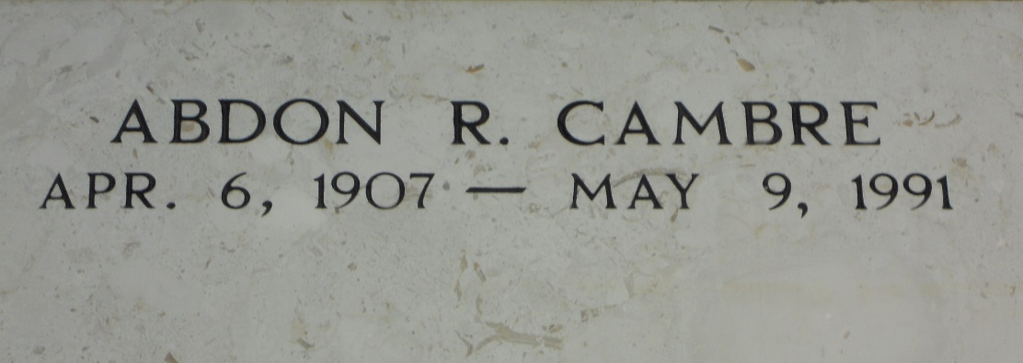

Photo by Team T-Lo

Abdon R Cambre, a native and resident of Laplace, Louisiana, died Thursday 9 May 1001 at 8:00 a.m. at age 84 years. He was the brother of Prudomme and Edward Cambre and is also survived by a number of nieces and nephews. Services were Saturday 11 May 1991 with interment in St Peter Cemetery, Reserve, Louisiana.  
  
The Times-Picayune, New Orleans, Louisiana

May 10, 1991