Alvin J. Cambre

October 19, 1914 – November 28, 1988

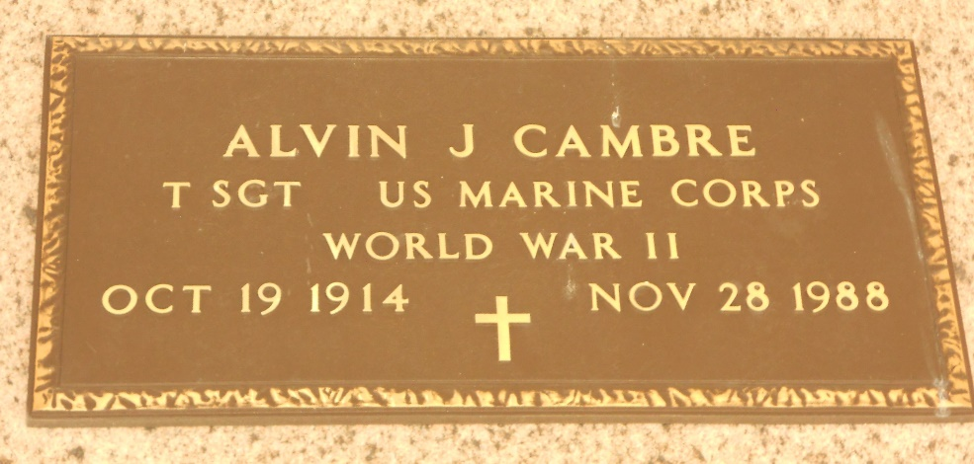

Photo by Team T-Lo

Alvin (Buzz) Cambre, a native and resident of Laplace, Louisiana, died Monday 28 Nov 1988 at 3:30 p.m. at age 74 years. He was the husband of Cecile M Cambre and the father of Kerry Cambre. He was the brother of Prudhomme, Abdon and Edward Cambre and the late Guy, Etienne and Ruth Cambre.

Services were Wednesday 30 Nov 1988 at St Joan of Arc Catholic Church, Laplace, with interment in St Peter Cemetery, Reserve, Louisiana.

The Times-Picayune, New Orleans, Louisiana

29 Nov 1988