Amelia Marie (Lasseigne) Cambre
March 11, 1876 – August 13, 1970

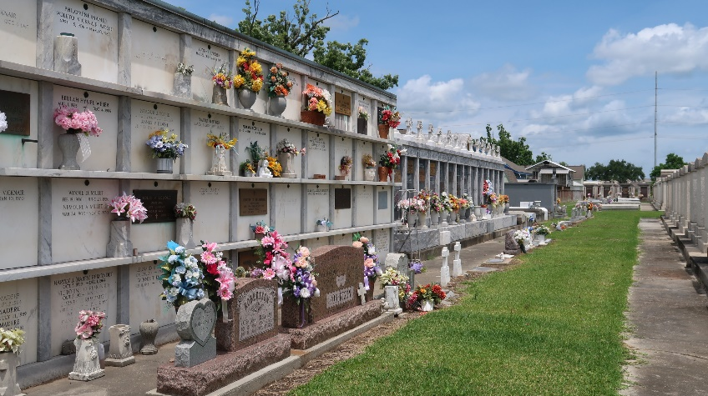
Photo by Team T-Lo

Funeral Held August 22 for Mrs. Cambre

Funeral services for Mrs. Amelia Lasseigne Cambre were held at 2:30 p.m. Saturday, August 15, with religious rites at the St. Hubert Catholic Church in Garyville and interment in St. Peter Cemetery, Reserve.
Mrs. Cambre, wife of the late Paul Ernest Cambre, died at 7:30 p.m. Thursday, August 13. A native of Reserve and a resident of Garyville, she was 94 years old.
Surviving Mrs. Cambre are three sons, Ernest Cambre of Garyville; Buell Cambre of Laplace and Gerard Cambre of Baton Rouge; three daughters, Mrs. Pierre Oubre, Sr., Garyville; Mrs. Raoul Laurent, Gramercy, and Mrs. Eddie Duhon, New Orleans; a sister, Mrs. Adam Lasseigne, 15 grandchildren and 36 great-grandchildren.

L’Observateur, LaPlace, Louisiana
August 20, 1970
Page 5B

