Antoinette (Millet) Cambre

February 7, 1887 – November 13, 1955

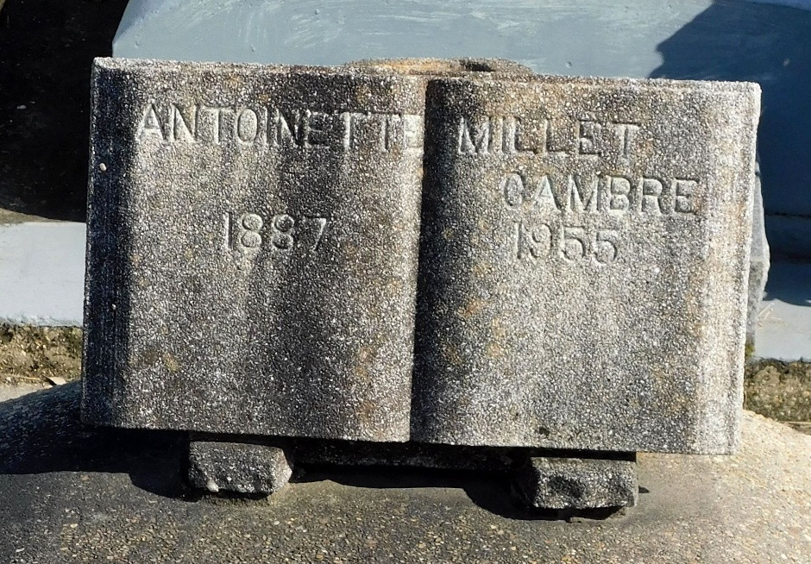

Photo by Mary Agnes Hammett

Age 68 years, 9 months and 6 days, a native and resident of Reserve, Louisiana. Wife of the late Adolph Cambre and sister of Sister Mary Therese of the Dominican Order, Samuel Millet and the late Clarence Millet. She was the daughter of Ernest Millet and Seraphine Millet. Services were Monday 14 Nov 1955 at St Peter Church, Reserve, with interment in St Peter Cemetery, Reserve.

The Times-Picayune, New Orleans, Louisiana

14 Nov 1955