Bernard A. Cambre, Jr.

March 9, 1934 – July 6, 2014

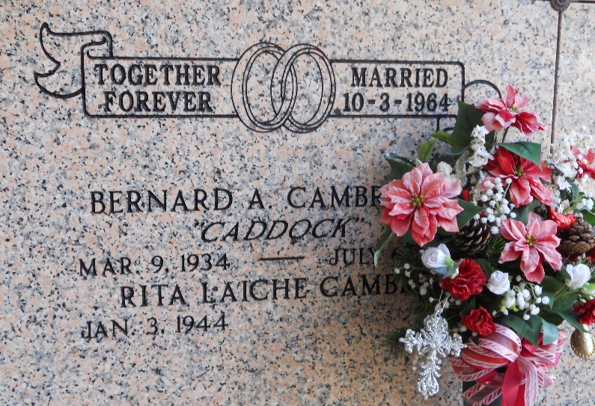

Photo by Team T-Lo

Bernard "Caddock" Cambre Jr. passed away on Sunday, July 6, 2014 at the age of 80. Beloved husband of Rita Laiche Cambre for 49 years. He was the loving father of Darlene Blank (Donald Jr.), Lisa Willis and Denise Adams(William). He was the proud grandfather of Brittany, Heather, Chase, Megan and Chelsey and great grandfather of Aurora, Bentson and Evangelina. He is survived by his siblings: Alma Keller, Mary Simon, Michelle, Terry, Stanley, Paul and Daniel Cambre. He is preceded in death by his parents Bernard and Adrienne Cambre and his siblings; Mable Hidalgo, Alice Herbert, Walter, Berince, and Betty Jean Cambre. He also leaves behind his loving dog BJ.

Bernard enjoyed fishing, hunting, doing woodwork, cooking and most of all spending time with his family and friends. He will be dearly missed by all.

Relatives and friends are invited to attend a visitation at St. Joan of Arc Church in LaPlace, La on Friday, July 11, 2014 from 10:00AM till 11:45AM. A Funeral Mass will be celebrated at 12 Noon. Interment will follow at St. Peter's Cemetery in Reserve, La. Condolences may be expressed at [www.hcalexanderfuneralhome.com](http://www.hcalexanderfuneralhome.com).

TheNewOrleansAdvocate.com

July 8 to July 11, 2014