Caliste Cambre

December 2, 1849 – April 4, 1918

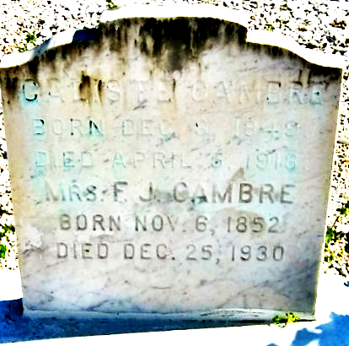

Photo by Bobby

"Death, the inevitable death, has again claimed another of our good citizens. Mr. Caliste Cambre, a life long resident of this parish, died Thursday afternoon at 3:30 o'clock, at his home, at Reserve, after an illness of some duration, at the age of 68 years and 4 months. The next day his remains were laid to rest in the family plot in St. Peter's cemetery after services at St. Peter's Church, the funeral being largely attended.

The deceased is survived by his devoted wife, three sons, Hebert, Lewis and Francois, three daughters, Mmes. Moise Jacob and Camille Naquin and Miss Georgina Cambre and a number of grandchildren."

L’Observateur, LaPlace, Louisiana

April 6, 1918

Page 1