Camelia Eugenie Cambre

February 21, 1886 – December 8, 1981

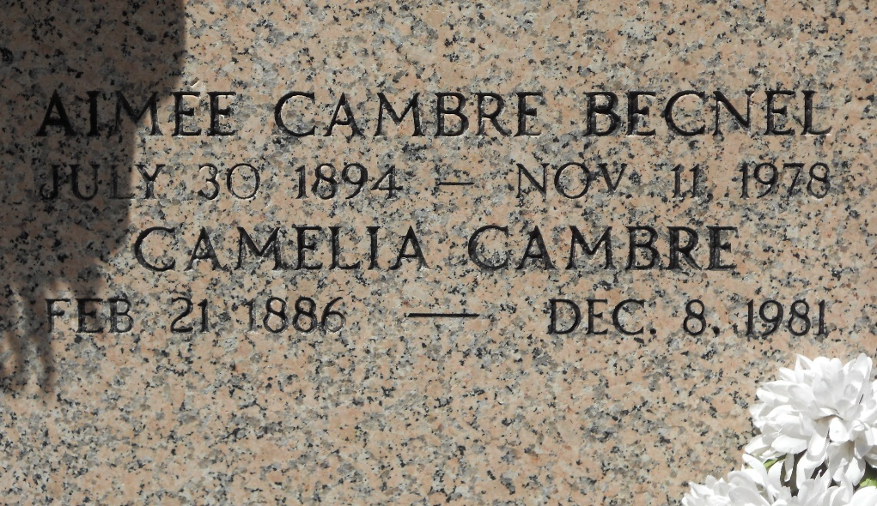

Photo by Team T-Lo

Age 95 years, a native of St John the Baptist Parish, Louisiana, and a resident of Norco, Louisiana, for the past 50 years.

Aunt of Mrs Milton (Kathleen) Cambre of Norco, sister of the late Aimee, Louis, Raoul, Anelis, and Oleus Cambre, Amire Montz, Louise Dufresne and Zeolide Laurent.

Services were Thursday, 10 Dec 1981 at Sacred Heart Church, Norco, with interment in St Peter Cemetery, Reserve, Louisiana.

The Times-Picayune, New Orleans, Louisiana

9 Dec 1981