Cecile (Maurin) Cambre
July 22, 1912 – February 21, 1999
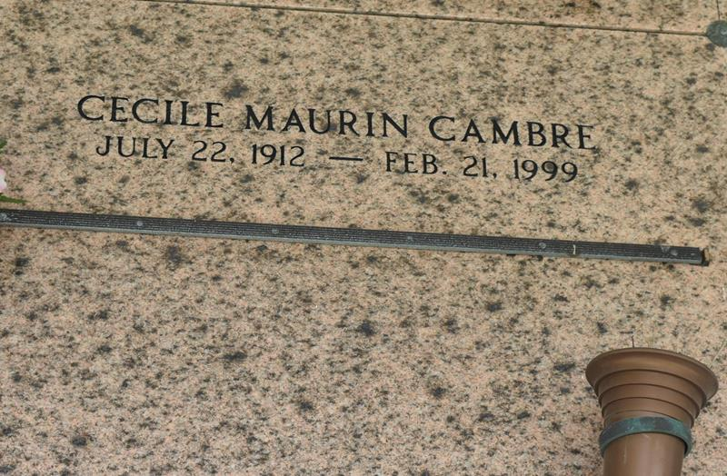

Cecile Maurin Cambre died Sunday 21 Feb 1999 at 4:30 pm, age 86 years. She was a native and resident of Laplace, Louisiana and the wife of the late Alvin (Buzz) Cambre. She was the mother of Kerry (Que) Cambre and the sister of Marian (Poose) Maurin, Juliette Maquar and the late Henry (Foot) Maurin and John Dan (Sam Spade) Maurin Sr.
Services were Wednesday 24 Feb 1999 at St Joan of Arc Church, Laplace, with interment in St Peter Cemetery, Reserve, Louisiana.
From Obituary, The Times Picayune, 23 Feb 1999
Contributed by Dwayne Montz

