Charles A. Cambre
1862 – August 9, 1911

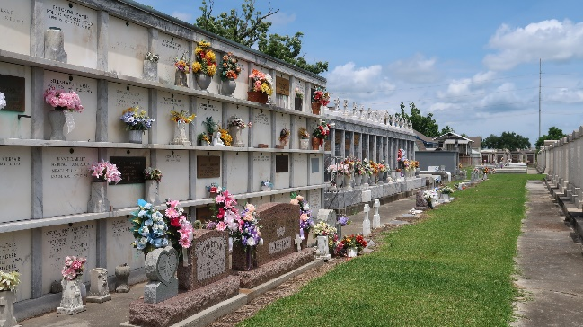

Charles A. Cambre, aged 49 years, a letter carrier for the past fifteen years, was prostrated by the heat Wednesday, 9 Aug 1911, shortly before 1 o'clock, and was taken to the Charity Hospital, where he died an hour later. Cambre had just returned from his noon delivery in the business district, and had complained of the heat as he had finished his lunch in the neighborhood of the Post Office building. He was returning to work when he was seen by Watchman Arthur Birou to drop to the pavement. An ambulance was summoned and he was promptly removed to the hospital where he died without having recovered consciousness.
Mr. Cambre was born in 1862 in St John the Baptist Parish and had been a resident of New Orleans for the past seven years where he has lived with his wife and children at 2134 Annunciation Street. He graduated from Jefferson College and also attended school in Troy, Missouri.
He was the son of Marcellite Montz and Lucien Cambre, a former sheriff of St John the Baptist Parish. He is survived by his wife of 29 years, Henriette Andry, two sons, Charles Louis and Lucien Gilbert Cambre, and two daughters, Mrs. James A [Lila] Clement and Edna Cambre. He also leaves a brother, William, and two sisters, Miss Blanche Cambre and Mrs. Edna Sanchez.
Funeral services were Thursday 10 Aug 1911 at St Peter's Church, Reserve, Louisiana.

Dwayne Montz

