Clara (Kennedy) Cambre

November 13, 1948 – May 11, 2003

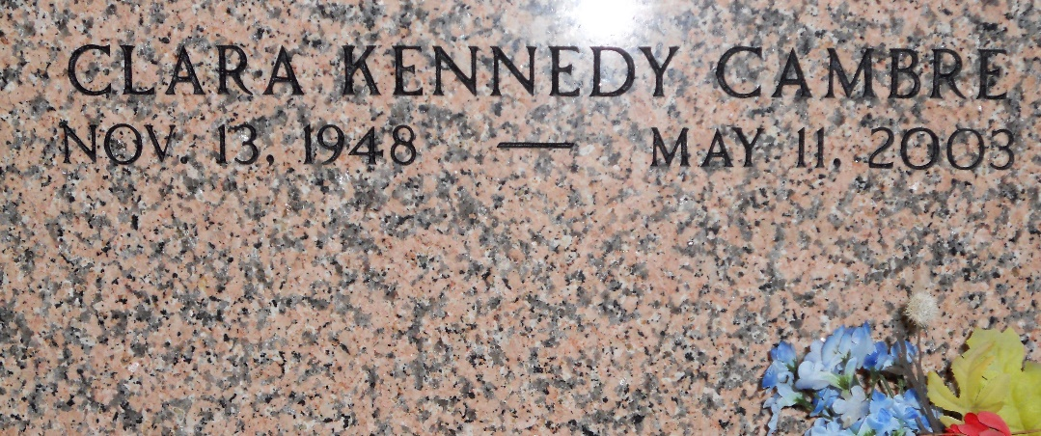

Photo by Team T-Lo

Clara Kennedy Cambre On Sunday May 11, 2003 At 2:30 P.M. Beloved Wife Of The Late Lionel 'Peck' Cambre Jr. Mother Of Thomas J. Cambre, Sr. Grandmother Of Thomas Jr And Zachary Cambre. Daughter Of The Late Harry And Mabel Elliott Kennedy. Sister Of Judy K. Georgel, June K. Heard, Sandra K. Laird, Vicki, John, Harry 'Pete' And William Kennedy And The Late James And Thomas Kennedy. Age 54 Years. A Native Of Louisiana, Missouri And A Resident Of Laplace For The Past 29 Years.

Relatives And Friends Of The Family Also Employees Of Stockhausen Louisiana Limited And Shell/Motiva Refinery Are Invited To Attend The Services. Visitation At Millet-Guidry Funeral Home, 2806 W. Airline Hwy, Laplace, LA On Wednesday May 14, 2003 From 5pm Until 9pm And On Thursday From 9am Until 10am At Ascension Of Our Lord Catholic Church, 1900 Greenwood, Laplace Followed By A Mass At 10am. Burial In St. Peter Church Cemetery, Reserve, LA.

Times Picayune, New Orleans, Louisiana

Mary 13, 2003