David Joseph Cambre Jr.
May 8, 1954 – May 12, 2020

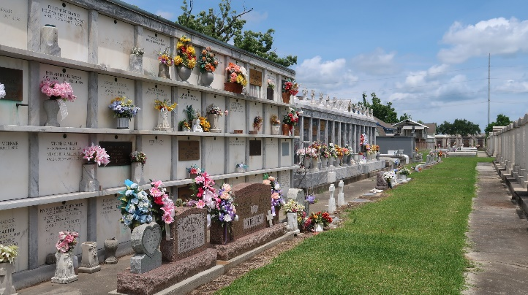

David "Boogie" Joseph Cambre, Jr. born May 8, 1954 entered into eternal rest on Tuesday, May 12, 2020 at the age of 66. Loving and devoted father to Timothy Paul Cambre (Krystal). Proud Grandfather and best friend to Drake Joseph Cambre.

He is preceded in death by his parents, David Joseph Cambre, Sr. and Evelyn Vicknair Cambre and his sister, Clarise Pendergast. Boogie was a native and current resident of Montz, LA and longtime resident of Norco, LA. He retired from Bunge North America and was a long time member of the Marsh Duck Club. He loved spending time with his family who enjoyed his story telling, and jokes. Boogie also loved to cook and enjoyed duck hunting. He will be greatly missed by all who were blessed to know him.

Family and friends are invited to attend a visitation at Sacred Heart Catholic Church located at 401 Spruce St. in Norco, LA on Saturday, May 16, 2020 beginning at 9AM, with a Mass of Christian Burial beginning at 10:30 AM. Interment to follow at St. Peter Cemetery in Reserve. Please remember to practice safe social distancing. H.C. Alexander Funeral Home in charge
Times Picayune, New Orleans, Louisiana
May 13-15, 2020

