Denise Elizabeth (Songy) Cambre
August 10, 1914 – March 10, 2005

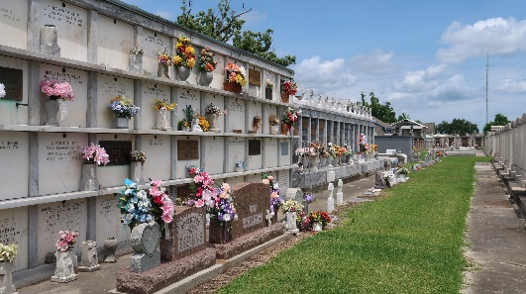

Denise Elizabeth Songy Cambre, A Homemaker And Longtime Resident Of Reserve, La. Died At North Shore Living Center, Slidell, La. On March 10, 2005 At 2:25 Pm. The Third Child Born To Justin And Palmyre Songy On August 10, 1914 She Was 90 Years Old. Beloved Wife Of The Late Francois Edward Cambre, Jr.,
She Is Survived By Six Children And Their Spouses: Mary Ann (Davant Madere) Of Cedar Creek, Texas; Ralph (Frances Calderone) Of Slidell, Louisiana; Arleen (Arthur Klaus) Of Joplin, Missouri; Francois Iii (Sandra Weber) Of Reserve, Louisiana; Joseph (Cathy Grant) Of Hampton, Arkansas; Paul Of Franklin, Tennessee. She Is Also Survived By 18 Grandchildren, 26 Great Grandchildren, One Sister, Doris Weber And One Sister-In-Law, Lucille Duhe.
She Was Preceded In Death By Her Parents; Her Husband; One Grandchild, Neil, One Brother, Edmond; And Four Sisters, Agnes, May, Pauline, And Clarisse.
Denise Was A Member Of The Third Order Carmelites And Altar Society In St. Peter's Parish In Reserve, The Sacred Heart League, The Confraternity Of Christian Mothers, And The Miraculous Medal Association.
Relatives And Friends Are Invited To Join The Family On Saturday, March 12th, At St. Peter's Church In Reserve From 12:30 Until Mass Celebration At 1:30 Pm. Interment Will Be In St. Peter's Catholic Cemetery. Pallbearers Are Her Grandsons.
Special Thanks To The Staff Of The North Shore Living Center For Their Love, Concern, And Care Especially In The Final Days. Arrangements By Millet-Guidry Funeral Home.
Times Picayune, New Orleans, Louisiana
March 11, 2005

