Doris Gertrude Cambre

November 15, 1921 – December 9, 1996

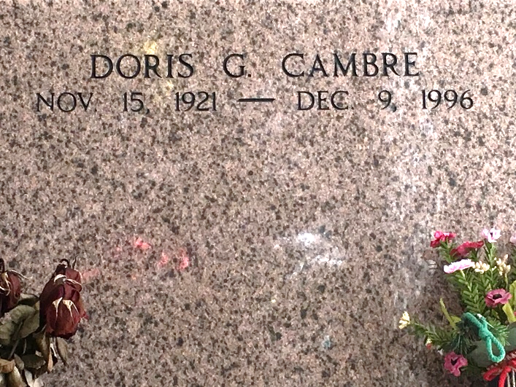

Photo by Team T-Lo

Doris G. Cambre died on Monday 9 Dec 1996 at 12:00 pm at age 75 years. She was a native and resident of Laplace, Louisiana, and the daughter of the late Douglas W. Cambre Sr and Florence Alexander Cambre.

She was the sister of Douglas (Rusty) Cambre Jr, and the late Falsen and Foster Cambre and Dazie C Duhe. She was the aunt of Roger and Roy Duhe, Brenda Stephens, Gwen Douglas, Janet Faucheaux, Karen Deslatte, Dale, Michael, Stanley, Douglas and Carol Cambre and the late Gregory Duhe and Malcolm Cambre.

Services were Wednesday 11 Dec 1996 at St Joan of Arc Church, Laplace, with interment in St Peter Cemetery, Reserve, Louisiana.

Times Picayune, New Orleans, Louisiana

December 10, 1996