Dorothy (Wilson) Cambre

November 7, 1912 – December 26, 2008

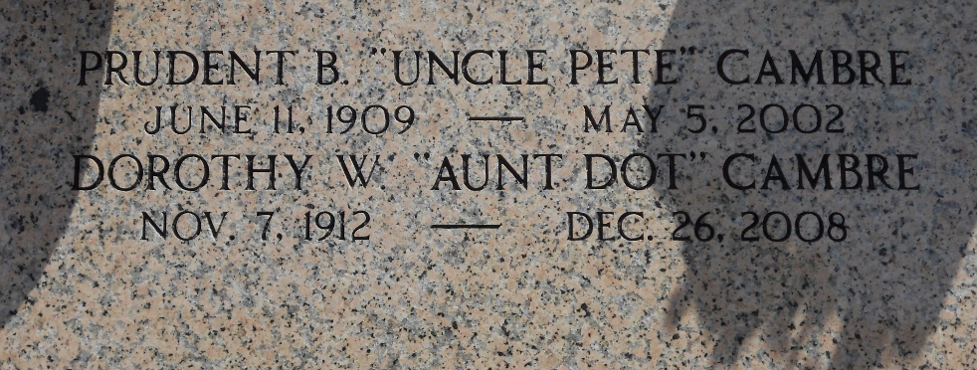

Photo by Team T-Lo

Dorothy Wilson Cambre, a native of Liberty Hill, Texas, and a resident of Bryan, Texas, for the past 13 years died Friday 26 Dec 2008 at 2:00 a.m. at age 96 years.

She was the wife of the late Prudent B Cambre and the daughter of the late James and Dora Russell Wilson. She was the sister of Irving Wilson and the late Bessie Lee Towry and William and John Wilson. Also survived by nieces and nephews.

Services were at the chapel of Millet-Guidry Funeral Home, 2806 W Airline Hwy, Laplace, Louisiana, on Friday 2 Jan 2009 with interment in St Peter Cemetery, Reserve, Louisiana.

Times Picayune, New Orleans, Louisiana

January 1, 2009