Douglas William Cambre Jr.
August 27, 1924 – March 24, 2020

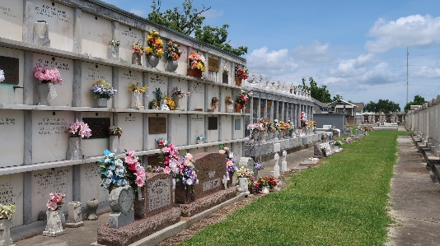

Douglas 'Rusty' William Cambre Jr. was born on August 27, 1924 and passed away on March 24, 2020 at the age of 95. He was a native and resident of LaPlace. Douglas also known as Papa Joe to family, was a devout Christian, wonderful father, family man, and friend.
Douglas proudly served our Country in the U. S. Army during WW II. He was awarded the Good Conduct Medal, Asiatic Pacific Service Medal and the Purple Heart Medal. He was a retiree of Dupont.
He is survived by his five children, Lottie Benoit (Ricky), Charles Madere, Jr. (Roxanne), Judy Conteras (Glenn), Harry Madere (Missy), and Kathy Louque (Jody); his second wife, Diann Doyle Cambre; and numerous grandchildren, great grandchildren, nieces and nephews. He was preceded in death by his first wife, Doris Bourgeois Cambre; parents, Douglas William Cambre, Sr. and Florence Della Alexandre Cambre; siblings, Doris Cambre, Falsen Cambre (Alberta), Foster Cambre (Therese), Dazie Duhe (Roger), and Della Cambre; granddaughter, Jennie Louque; and great grandson, Christian "Cookie" Newman.
A special thanks to the Southeast Louisiana Veterans Home for the care given during his stay and to Ochsner Medical Center - Kenner for the comfort and support during his final time there.
As a result of present circumstances, the funeral and committal services are private, but our community of friends are important to us. Please consider sharing your thoughts, favorite memory or condolences at
www.milletguidry.com. A public Memorial Mass and Military Honors to be announced and held at a later date.
Times Picayune, New Orleans, Louisiana
March 25-26, 2020

