Douglas William Cambre Sr.

October 13, 1886 – September 11, 1944

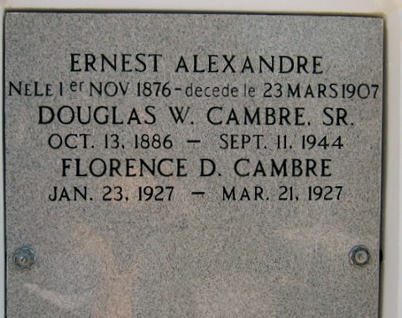

Photo by Bobby

Douglas William Cambre Sr. died Monday 11 Sep 1944 at 4:30 pm at age 57 years, 11 months and 2 days.

He was the husband of Florence Alexander and the father of Mrs. Roger Duhe, Corporal Falsen Cambre, Private First Class Douglas W. Cambre Jr, U S Army, and Foster and Doris Cambre of Laplace, Louisiana.

Services were Wednesday 13 Sep 1944 with interment in St Peter Cemetery, Reserve, Louisiana.

Unknown source