Earlie (Nichols) Cambre

April 6, 1937 – January 25, 2001

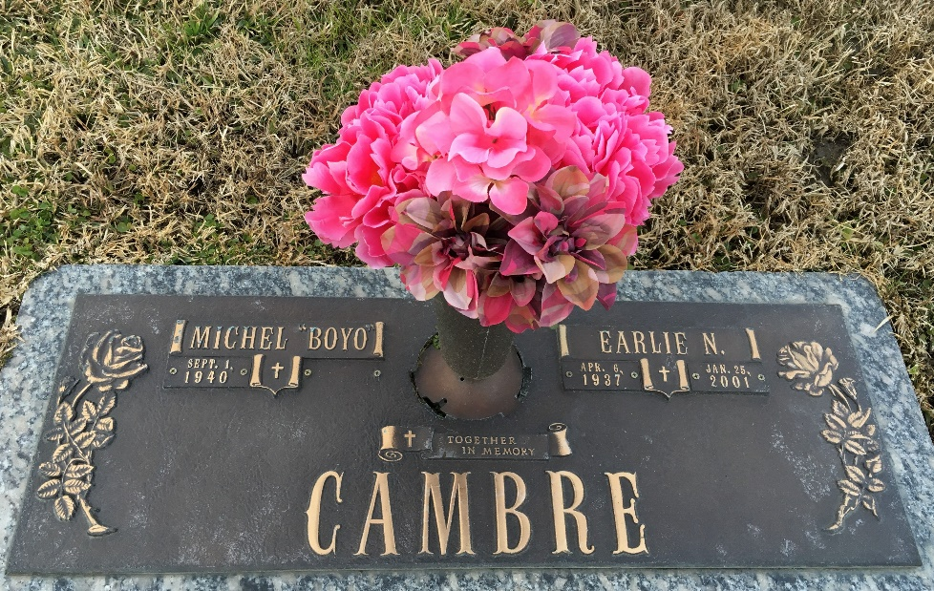

LAPLACE – Valerie Elvin Earlie Cambre, 63, a native of Mississippi and resident of LaPlace for 34 years, died Jan. 25.  
  
She was the wife of Michael “Boyo” Cambre Sr. and mother of Michael Cambre Jr., Deborah Cortez, Linda Smitty, Denise Thompson, Charles, Richard and Gregory Doster and the late Lisa Marie Butter and Randy Doster.  
  
She was also the daughter of Juanita Nichols and the late Alvin Nichols and sister of Evelyn Dinkin and Charles, Wilton Nichols and the late Durell Nichols. She is also survived by 19 grandchildren.  
  
Services were Jan. 30 in the chapel of Millet-Guidry Funeral Home, LaPlace, with interment at St. John Memorial Gardens, Laplace.

Unknown source