Edgar Joseph Cambre Sr.
October 17, 1921 – July 20, 1998

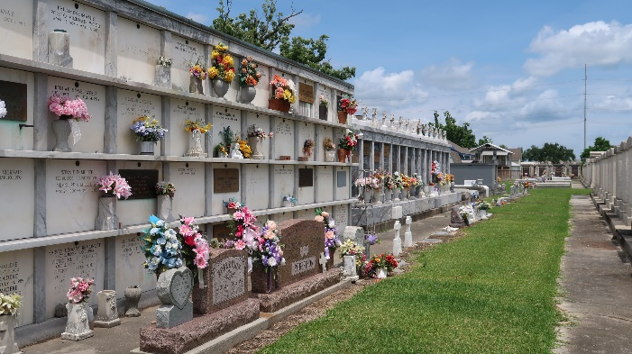

Edgar Joseph 'Bulleye' Cambre Sr., A Retired Operator For Godchaux Henderson Sugar Refinery And An Employee Of Finish Line Offtrack Betting, Died Monday Of Cirrhosis Of The Liver At River Parishes Hospital. He Was 76. Mr. Cambre Was Born In Garyville And Lived In Reserve For Many Years. He Was An Army Veteran Of World War Ii.
Survivors Include His Wife, Helen Cureau Cambre; Five Sons, Barry Cambre Of Laplace, Randy Cambre Of Houston And Andouche, Hollis And Edgar Cambre Jr.; Six Daughters, Terry Wilson Of Laplace, Paulette Montgomery Of Houston, Barbara Rivers, Paula Joseph, Claudette Taylor And Fedora Johnson; Two Sisters, Mable And Ceola Taylor; 30 Grandchildren; And Four Great-Grandchildren.
A Mass Will Be Said Friday At 11 A.M. At Our Lady Of Grace Catholic Church In Reserve. Visitation Will Begin At 9 A.M. Burial Will Be In St. Peter's Catholic Cemetery In Reserve. Robottom Mortuary Is In Charge Of Arrangements.

Times Picayune, New Orleans, Louisiana
July 23, 1998

