Edma (Duhe) Cambre

June 4, 1910 – December 16, 1984

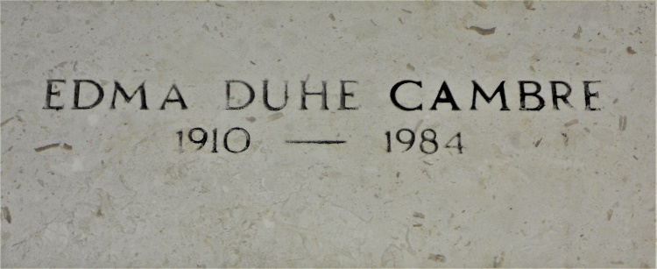

Photo by Team T-Lo

Edma Duhe Cambre, a native of Reserve, Louisiana, and a resident of Laplace, Louisiana for the past 51 years, died Sunday 16 Dec 1984 at 8:30 pm at age 74 years.

She was the wife of Guy Cambre and the mother of Guy Cambre Jr of Newart, Delaware, and Donald Cambre of Laplace. She was the daughter of the late Gustave and Zoe Duhe and sister of the late Leon and Joseph Duhe and Lydie Duhe Smith.

Services were Wednesday 19 Dec 1984 at St Joan of Arc Church, Laplace, with interment in St Peter Cemetery, Reserve.

Times Picayune, New Orleans, Louisiana

December 18, 1984