Elsie (Matherne) Cambre

August 25, 1927 – February 5, 2013

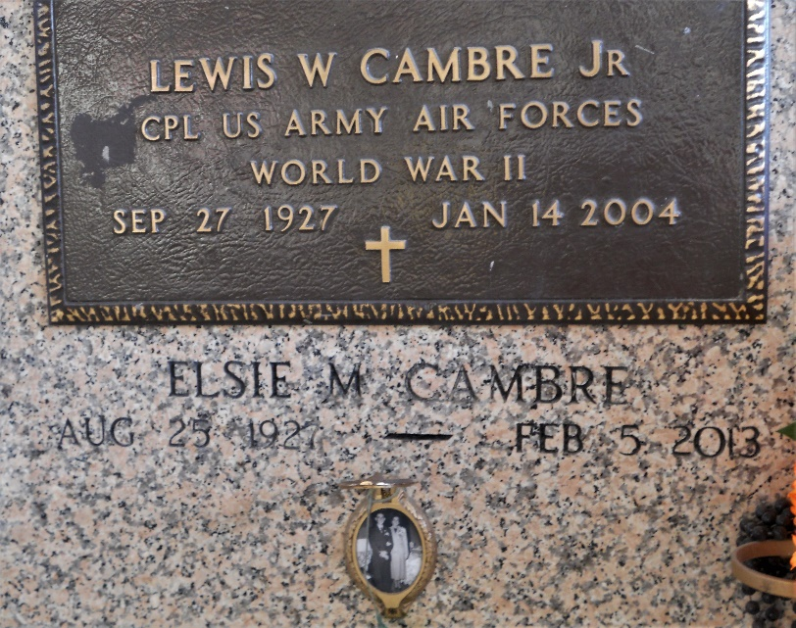

Photo by Team T-Lo

Elsie Matherne Cambre passed away on Tuesday February 5, 2013.  
 Beloved wife of the late Lewis Cambre Jr., Mother of Kathleen Cambre, Marie Ursa (Charles), Lewis Cambre III (Carla), Lyle Cambre (Drema) and Elsie Cambre. 12 grandchildren and 25 great-grandchildren.  
 Daughter of the late Charles and Leona Matherne. Sister of Inez Duhon Blank and the late Joseph, Adam, Sidney and Charles Matherne Jr., Eunice Miller, Elise Zeringue and Gertrude Brady.  
 She was a member of St. Hubert Altar Society, Catholic Daughters, RSVP, River Parish Hospital Volunteer, St. John Parish CAP, Garyville VFW Auxiliary. Age 85.  
 A native and resident of Garyville, LA. Relatives and friends are invited to attend services. Visitation at Millet-Guidry Funeral Home, LaPlace, LA on Friday February 8, 2013 5:00 pm to 9:00 pm and on Saturday at St. Hubert Catholic Church, Garyville, LA from 8:00 am to 10:00 am, followed by Mass at 10:00 am. Burial in St. Peter Cemetery, Reserve, LA.

Times Picayune, New Orleans, Louisiana

February 5-6, 2013