Ernestine (Madere) Cambre
March 14, 1883 – February 10, 1966
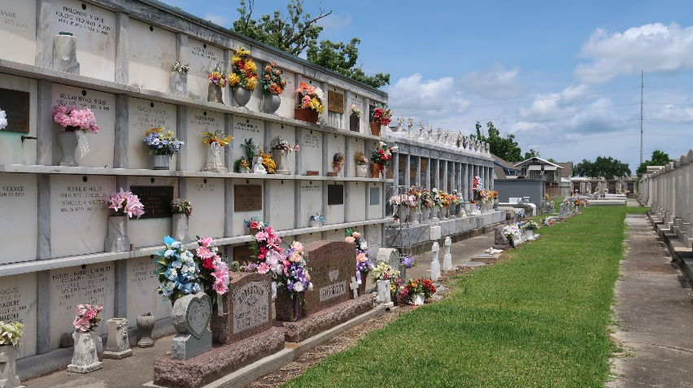

CAMBRE – On Thursday, February 10, 1966, at 7:30 p.m. Ernestine Madere, wife of the late Henry D. Cambre; mother of Mary Mabel Cambre, daughter of the late Ernest Madere and Rosema Clement, and sister of the late Marie, Leonce, Omer, Charles, Willie and Renest Mardere, Mrs Elanore Gueret and Mrs. leontine Vicknair; also survived by many nieces and nephews; age 83 years, a native of Reserve, La. And a resident of Metairie, La.

Relatives and friends of the family are invited to attend the funeral. Services from Millet Funeral Home, Reserve, La. On Saturday, February 12, 1966, at 10 o’clock a.m. Religious services at St. Peter’s Church, Reserve, La. Interment in St. Peter’s Cemetery, Reserve, La.

Unknown newspaper clipping

