Etienne ‘Jack’ Cambre
July 3, 1902 – May 14, 1988

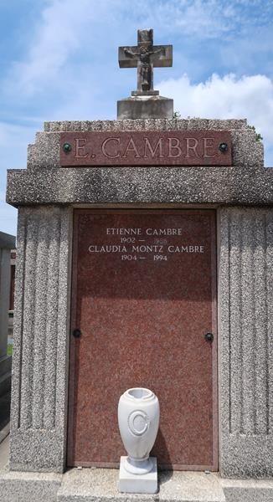

Etienne (Jack) Cambre, a native and resident of Laplace, Louisiana, died Saturday 14 May 1988 at 2:00 a.m. at age 85 years.
He was the husband of Claudia Montz Cambre and the father of Madge Cambre Perilloux of Hahnville, Louisiana. He was the brother of Abdon, Prudent, Edward and Alvin Cambre and the late Guy and Ruth Cambre. Also survived by 3 grandchildren.
Services were Monday 16 May 1988 at the chapel of Millet-Guidry Funeral Home, 2808 West Airline Hwy, Laplace, with interment in St Peter Cemetery, Reserve, Louisiana.
The Times-Picayune, New Orleans, Louisiana
15 May 1988

