Eva (Dufresne) Cambre
June 27, 1871 – August 19, 1931

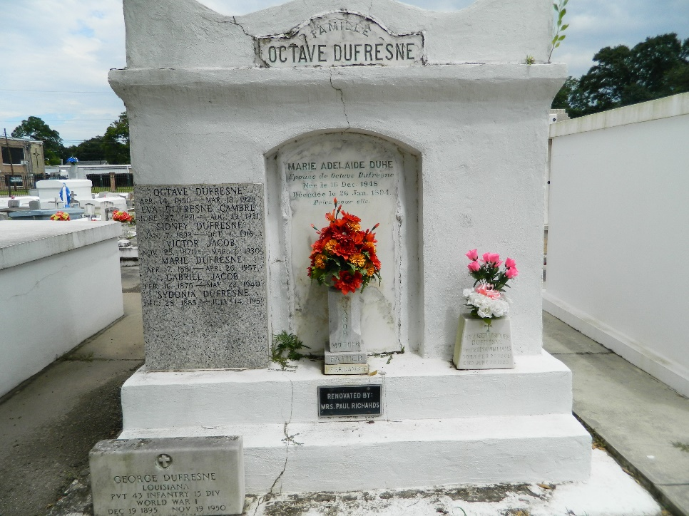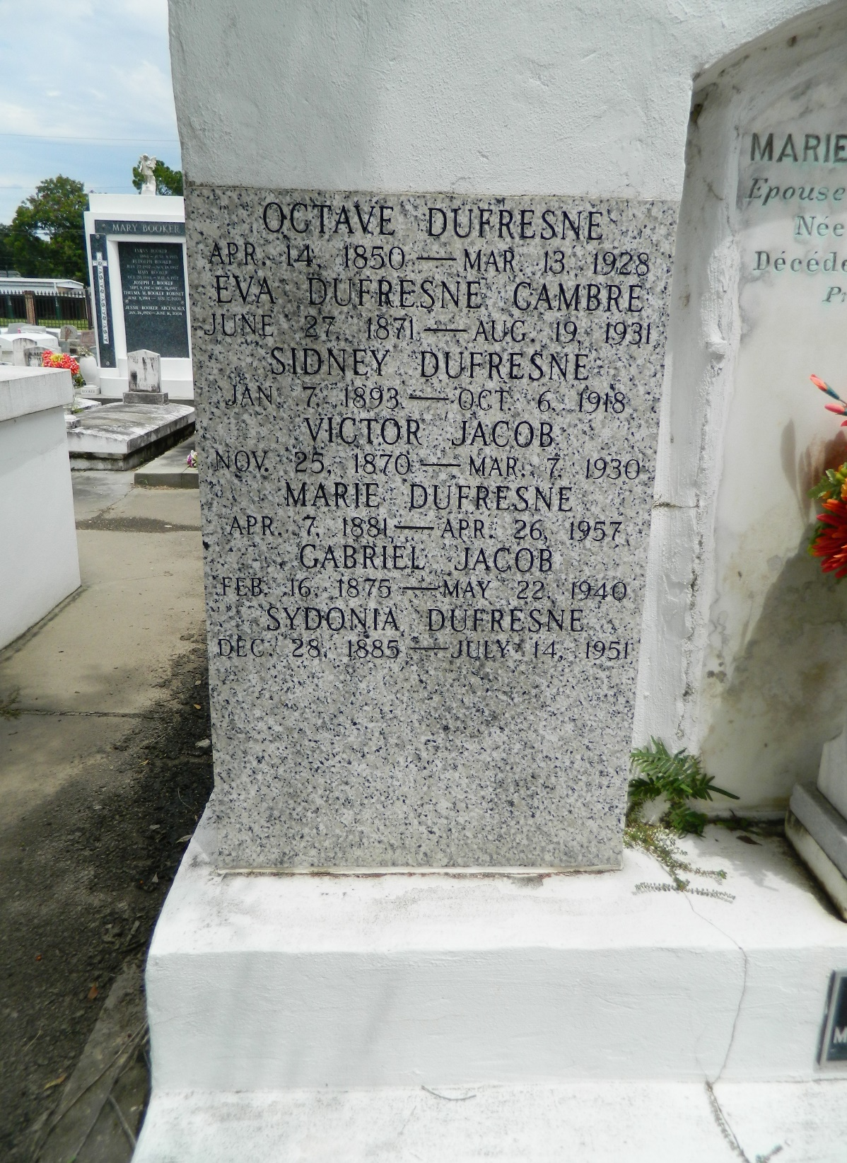

Mrs. Raoul P. Cambre, neé Eva Dufresne, of Laplace, LA, died Wednesday morning 19 Aug 1931 at age 60 years.
Leaves husband and 6 sons and 1 daughter.
Interment St Peter Cemetery, Reserve, LA., Thursday, 20 Aug 1931.
L'Observateur, LaPlace, Louisiana
22 Aug 1931

