Fanelie (Borne) Cambre
February 14, 1908 – June 11, 2003

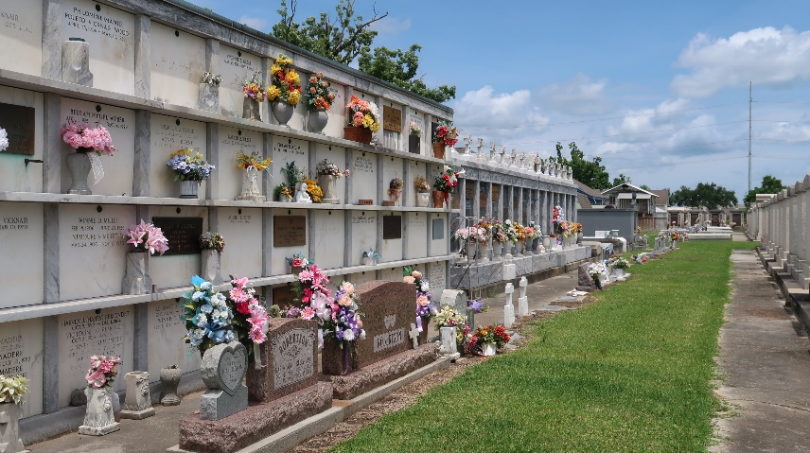

Fanelie Borne Cambre died Wednesday 11 Jun 2003 at age 95 years. She was a native of Lucy, Louisiana, and a resident of Reserve, Louisiana, for the past 80 years.
She was the wife of the late Sidney Walter Cambre and mother of Iris C Kobrock of River Ridge, Louisiana, Irene C Garrard of Winter Haven, Florida, and Margaret C Cerami of LaPlace, Louisiana, and the late Anaise C Champagne and Sidney Ann Cambre. She was the daughter of the late Alcide and Anaise Borne. Also survived by 11 grandchildren and 16 great grandchildren. Sister of the late Kenneth, Henry, Clay, Emma (Sister Albina, C.S.J.) and Louise Borne, Emelie Edrington and Edith Politz.
Services were Saturday 14 Jun 2003 at St Peter Catholic Church, Reserve, with interment in St Peter Cemetery, Reserve.
The Times-Picayune, New Orleans, Louisiana
June 13, 2003

