Gabriel Alexander Cambre
October 23, 1897 – November 27, 1972

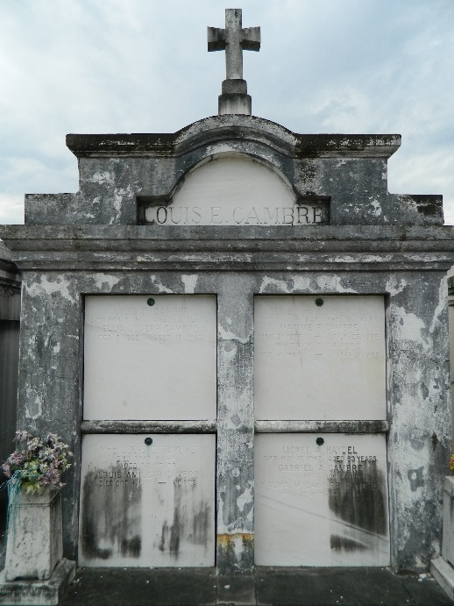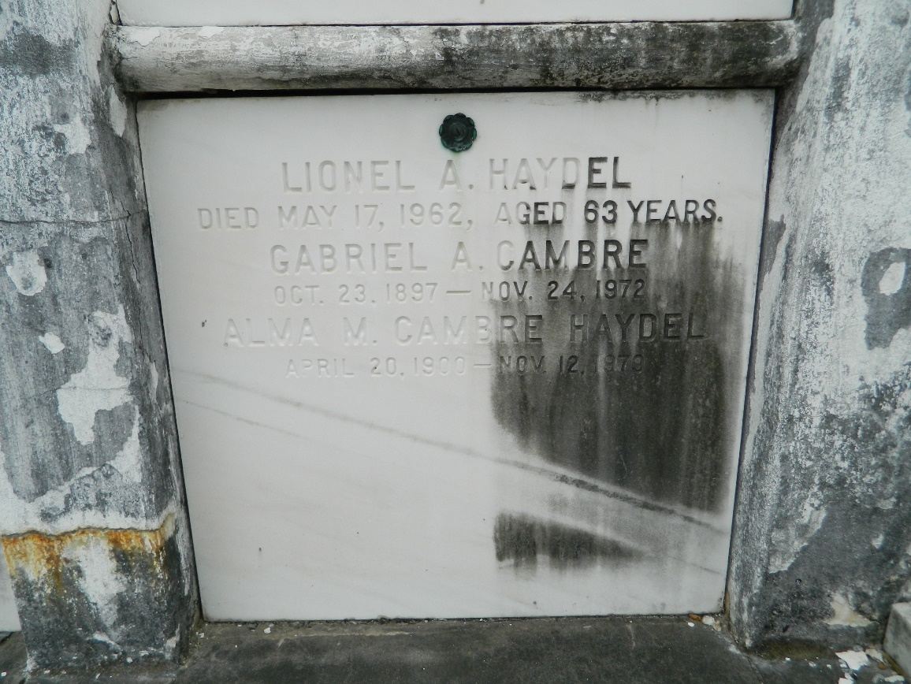

Gabriel (Gabie) Alexander Cambre, a native of Laplace, Louisiana, and a resident of New Orleans for the past 11 years, died Friday 24 Nov 1972 at 4:30 p.m. at age 75 years.
He was the husband of the late Vivian Robinson Cambre and father of Mrs. John (Connie) Barry of New Orleans. He was the brother of Mrs. Alma Haydel of New Orleans, Walter, Whitney and Maxine Cambre all of Laplace, and Ellis Cambre of Jefferson Parish, Louisiana, and the late Amilcar and Denise Cambre. Also survived by three grandchildren.
Services were Monday 27 Nov 1972 at St Joan of Arc Church, Laplace, with interment in St Peter Cemetery, Reserve, Louisiana.

The Times-Picayune, New Orleans, Louisiana
November 27, 1972

