Guy C. Cambre Sr.

October 2, 1904 – June 17, 1986

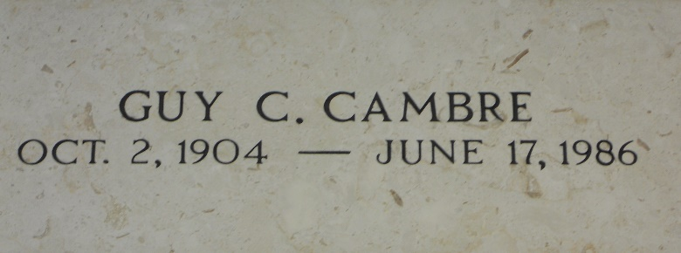

Photo by Team T-Lo

Guy C. Cambre Sr, a native and resident of Laplace, Louisiana, died Tuesday 17 Jun 1986 at 4:33 p.m. at age 81 years.

He was the husband of the late Edma Duhe Cambre and the father of Guy Jr and Donald Cambre. He was the brother of Etienne, Abdon, Prudent, Edward and Alvin Cambre and the late Ruth Cambre. He is also survived by five grandchildren and one great-grandchild.

Religious services were Friday 20 Jun 1986 at St Joan of Arch Catholic Church in Laplace with interment in St Peter Catholic Church Cemetery in Reserve, Louisiana.

The Times-Picayune, New Orleans, Louisiana

June 19, 1986