Harris Cambre

October 31, 1877 – September 12, 1953

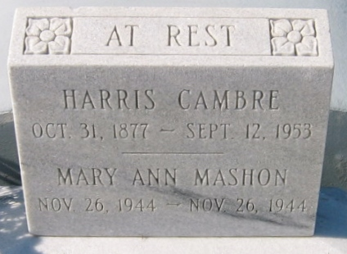

Photo by Bobby

Harris Cambre died Saturday 12 Sep 1953 at 7:40 p.m. at age 77 years.

He was the husband of the late Clementine Fourroux and the father of Mrs. Sidney Gonzales, Mrs. Laurence Michel, Mrs. Helen Mashion, Henry, Lance, Melvin, Frank, Louis, James and Albert Cambre.

Services were Monday, 14 Sep 1953 at St Hubert Church, Garyville, Louisiana, with interment in St Peter Cemetery, Reserve, Louisiana.

The Times-Picayune, New Orleans, Louisiana

September 14, 1953