Helen (Cureaux) Cambre

January 7, 1928 – November 17, 2015

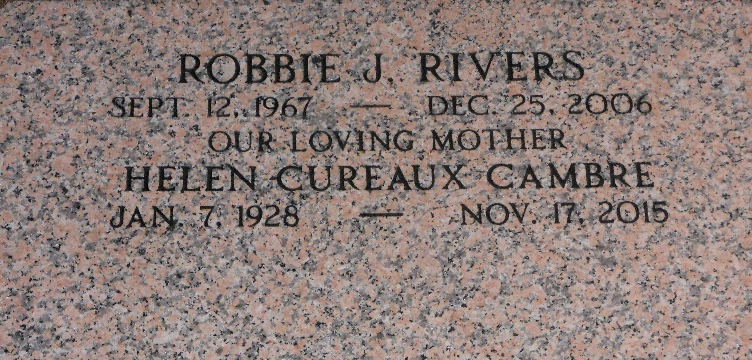

Photo by Team T-Lo

Helen Cureaux Cambre on Tuesday, November 17, 2015 at her home in Reserve, LA.

Daughter of the late Rose Conrad and Andouche Cureaux. Wife of the late Edgar Joseph Cambre. Mother of Barbara Rivers, Edgar Cambre, Terry Gardner, Paulette Montgomery, Paula Joseph, Barry Cambre, Claudette Taylor, Andouche Cambre, Randy Cambre, Fedora Johnson, Hollis Cambre, the late Joyce Ann and Aaron Cambre. Sister of Roy Cureaux, Anna Mae Fredericks, the late Hilda Billups, Alvin Cureaux, Harold Cureaux, Roland Cureaux, Mildred Campbell and Betty Roberts. Also survived by 34 grandchildren, 48 great grandchildren, 2 great great grandchildren and a host of nieces, nephews, cousins, other relatives and friends. Age 87 years. A native and resident of Reserve, LA.

Relatives and friends of the family, also priest and parishioners of Our Lady of Grace Catholic Church and all neighboring churches and employees of Shell Motiva, St. John Parish School and Louis Dreyfus are invited to attend the Funeral Mass at Our Lady of Grace Catholic Church, 772 Hwy 44 (River Road), Reserve, LA on Monday, November 23, 2015 at 10:00 AM. Father Christopher Amadi, Celebrant. Interment St. Peter Cemetery, Reserve, LA. Visitation at the above named church from 8:15 AM until Mass time. Rosary at 9:15 AM. SERVICED BY ROBOTTOM.

The Times-Picayune, New Orleans, Louisiana

November 20-22, 2015