Henriette (Andry) Cambre
October 22, 1862 – December 24, 1937

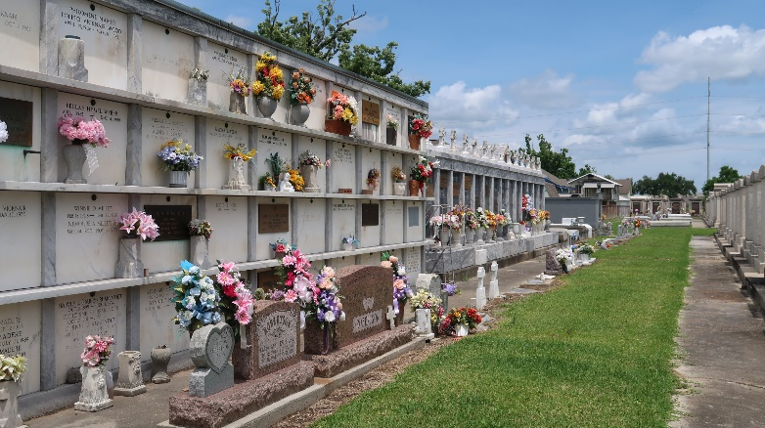

CAMBRE - On Friday, December 24, 1937, at 9:38 o'clock a.m., HENRIETTE ANDRY, widow of Charles A. Cambre, mother of Mrs. J. A. Clement of New Orleans, Mrs. W. T. Fannaly of Ponchatoula, La, and the late Louis and Gilbert Cambre, sister of Laura and Louis P. Andry of Laplace, La, age 75 years, a native of Louisiana and a resident of New Orleans for many years.

The funeral will take place from the funeral home of Prescott and Schopp, 4820 Magazine street, this (Saturday) afternoon, December 25, 1937, at 12:30 o'clock. Services at Our Lady of Lourdes Church at 1 o'clock. Interment in Reserve, La.

The Times-Picayune, New Orleans, Louisiana
December 25, 1937
Page 2

