Herbert Cambre Jr.
1930 – October 8, 2004

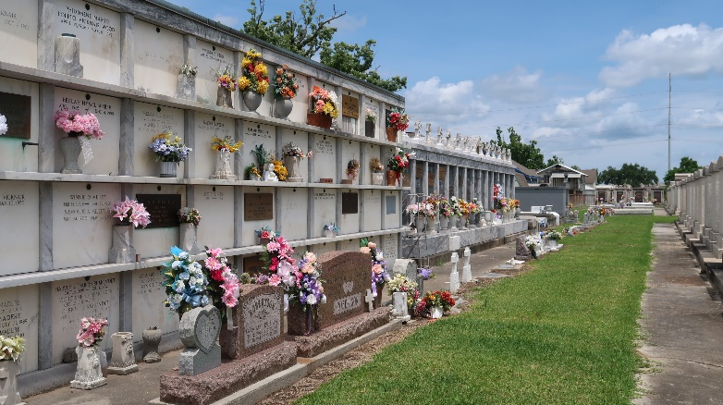

Herbert Cambre, Jr. 'Blue' On Friday, October 8, 2004 At Ormond Nursing And Care Center, Destrehan, La.

Son Of The Late Herbert Cambre Sr. And Louise Humphrey Gray. Stepson Of The Late Albert Gray. Husband Of Shirley W. Cambre. Father Of Tessa C. Arceneaux And Tanza Hamilton. Brother Of Anthony Cambre, Mary Elizabeth Mack And The Late Mary Pollard, Vernon And Edward Cambre. Also Survived By 4 Grandchildren And A Host Of Nieces, Nephews, Other Relatives And Friends. Age 74 Years. A Native And Resident Of Reserve, La.

Relatives And Friends Of The Family, Also Priest And Parishioners Of Our Lady Of Grace Catholic Church, Pastors, Officers And Members Of Bethlehem And Rescue Mission Baptist Churches And All Neighboring Churches Are Invited To Attend The Funeral Service At Our Lady Of Grace Catholic Church, 772 Highway 44 (River Road), Reserve, La On Thursday, October 14, 2004 At 10 Am. Father Joseph Rodney, Celebrant. Interment St. Peter Cemetery, Reserve, La. Visitation At The Above Named Church From 9:15 Am Until Service. Serviced By Robottom

The Times-Picayune, New Orleans, Louisiana
October 13, 2004

