James Andrew Cambre Jr.

September 1, 1911 – April 20, 1997

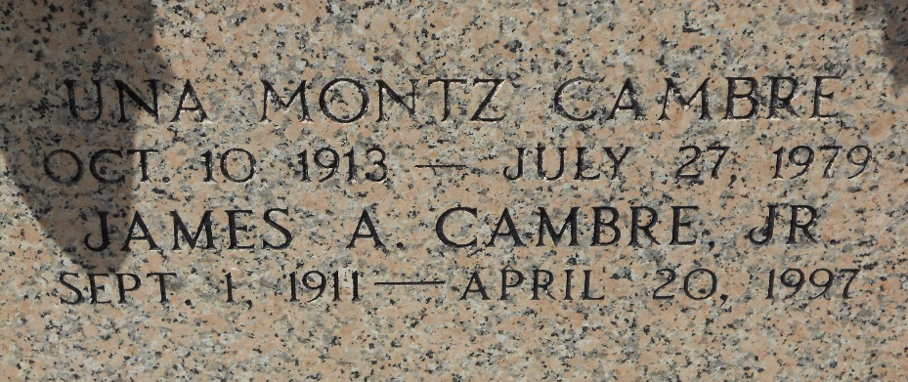

Photo by Team T-Lo

J. A. Cambre Jr, 85, a native of Laplace and a resident of Reserve, died 20 Apr 1997.

He was the husband of the late Una M. Cambre and the father of Kendall and James A Cambre III. He was also the brother of Alvin "Fist" Cambre, Leona Heltz and the late Iola Cambre Catoire. He is also survived by five grandchildren and two great grandchildren.

He was an honorary life member of Monsignor Jean Eyraud Council No 24361 Knights of Columbus.

Services were held 23 April 1997 at St Peter Catholic Church in Reserve with interment in the church cemetery.

L'Observateur, Reserve, Louisiana

26 Apr 1997