James Andrew Cambre Sr.

November 3, 1881 – April 15, 1951

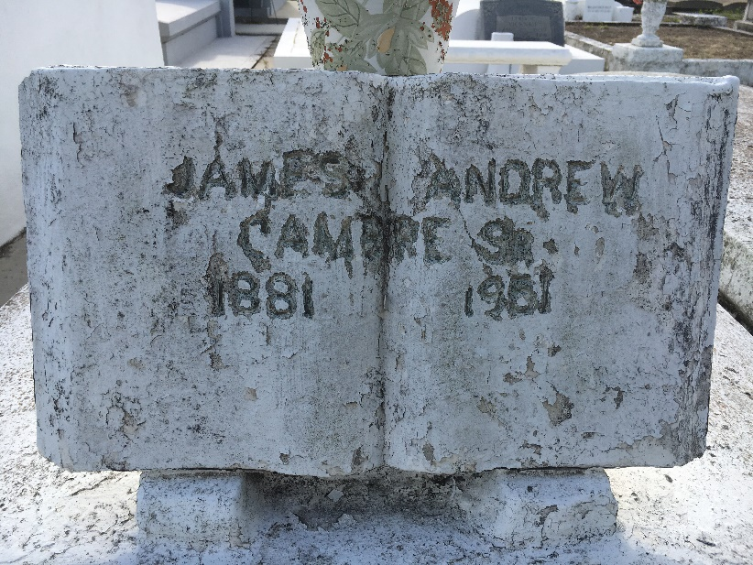

Photo by Team T-Lo

Andrew Cambre died Sunday 15 Apr 1951 at 1:30 p.m. at age 69 years.

He was the husband of the late Louise Elfer and father of Mrs. Lawrence Heltz, Mrs. Henry Catoire, J. A. Jr and Alvin Cambre.

Relatives and friends of the family are invited to attend the funeral from Millet Funeral Home, Reserve, Louisiana, on Monday, 16 Apr 1951 followed by religious services at St Peter Church, Reserve. Interment in St Peter Cemetery, Reserve.

The Times-Picayune, New Orleans, Louisiana

16 Apr 1951